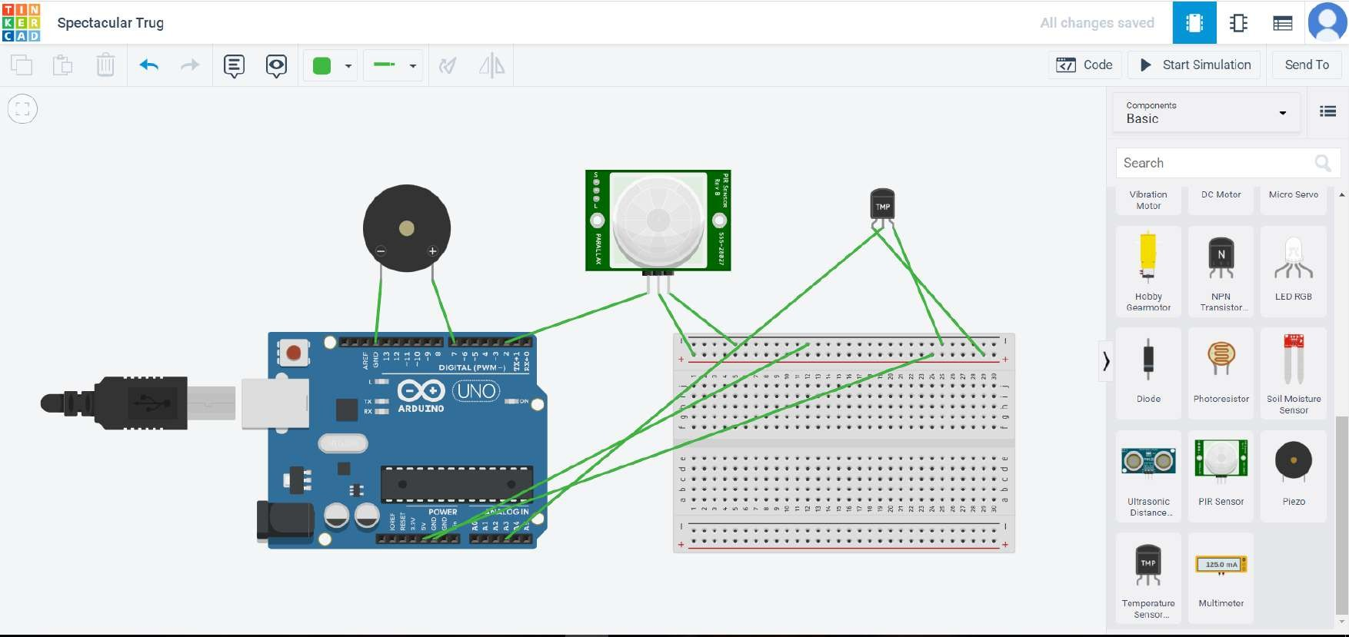ASSIGNMENT-1

PROGRAM:

int pinSensor =2;

int pinBuzzer =7;

int pirSensor =0; float sensor=A3; float analog; float tempv; float tempc; float tempf;

void setup()

{

pinMode(pinSensor, INPUT); pinMode(sensor, INPUT); pinMode(pinBuzzer, OUTPUT); Serial.begin(9600);

}

void loop()

{

analog=analogRead(sensor); tempv=analog\*5.0/1023; tempc=(tempv-0.5)\*100.0; tempf=((tempc\*9.0)/5.0)+32.0; Serial.print("temperature:");

Serial.println(tempc); if (tempc >=60)

{

tone(pinBuzzer, 200, 100);

}

delay(100);

pirSensor = digitalRead(pinSensor); if (pirSensor == HIGH)

{

tone(pinBuzzer, 1000, 500);

}

delay(100);

}